# Task Management System

Linked lists are fundamental data structures used in computer science to store a collection of elements. They consist of nodes where each node holds a value and a reference (or pointer) to the next node in the sequence. Here’s an overview of the different types of linked lists:

**1. Singly Linked List**

**Definition:**

A singly linked list is a type of linked list where each node points to the next node in the sequence, and the last node points to `null`, indicating the end of the list.

**Structure:**

Node: Contains two components:

Data: The value or information stored in the node.

Next: A reference to the next node in the list.

**Characteristics:**

**Unidirectional**: Traversal is only possible in one direction, from the head to the end.

**Simple**: Easier to implement and manage compared to other types of linked lists.

**Insertion**/**Deletion**: Efficient at inserting and deleting nodes at the beginning of the list. Inserting or deleting nodes elsewhere requires traversal.

**Operations:**

**Traversal**: Visit each node starting from the head and follow the `next` references.

**Insertion**: Add a node at the beginning, end, or any position by adjusting references.

**Deletion**: Remove a node by updating the `next` reference of the previous node.

**Example Code:**

class Node {

int data;

Node next;

public Node(int data) {

this.data = data;

this.next = null;

}

}

class SinglyLinkedList {

private Node head;

public SinglyLinkedList() {

head = null;

}

// Methods for insertion, deletion, traversal, etc.

}

**2. Doubly Linked List**

**Definition:**

A doubly linked list is a type of linked list where each node contains two references: one to the next node and one to the previous node. This allows traversal in both directions.

**Structure:**

Node: Contains three components:

Data: The value or information stored in the node.

Next: A reference to the next node in the list.

Previous: A reference to the previous node in the list.

**Characteristics:**

**Bidirectional**: Traversal is possible in both directions (forward and backward).

**More Complex**: Requires additional memory for the `previous` reference, and insertion/deletion operations involve updating two references.

**Flexibility:** Provides greater flexibility for operations that require bidirectional traversal

**Operations:**

Traversal: Can traverse forward or backward using the `next` and `previous` references.

**Insertion**: Can insert nodes at the beginning, end, or any position with ease, considering both `next` and `previous` references.

**Deletion:** Removing a node is more efficient since both `next` and `previous` references are updated.

**Example Code:**

class Node {

int data;

Node next;

Node previous;

public Node(int data) {

this.data = data;

this.next = null;

this.previous = null;

}

}

class DoublyLinkedList {

private Node head;

private Node tail;

public DoublyLinkedList() {

head = null;

tail = null;

}

// Methods for insertion, deletion, traversal, etc.

}

**Comparison**

Directionality:

Singly Linked List: Unidirectional.

Doubly Linked List: Bidirectional.

Memory Usage:

Singly Linked List: Requires less memory per node (only one reference).

Doubly Linked List: Requires more memory per node (two references).

Complexity:

Singly Linked List: Simpler to implement and manage.

Doubly Linked List: More complex due to additional `previous` reference but offers more flexibility in operations.

Performance:

Inserting or deleting nodes at both ends is generally more efficient in a doubly linked list due to bidirectional references, but managing these references can be more complex.

Each type of linked list has its use cases depending on the specific requirements of the application.

**Time Complexity Analysis**

Let's analyze the time complexity of each operation for the `SinglyLinkedList` implementation provided:

1. Adding a Task (`addTask` method)

- Operation: Appending a task to the end of the list.

- Time Complexity: O(n)

- Explanation: To add a task to the end, you need to traverse the entire list to find the last node. This traversal takes O(n) time, where n is the number of nodes in the list

2. Searching for a Task (`searchTask` method)

- Operation: Finding a task by its ID.

- Time Complexity: O(n)

- Explanation: In the worst case, you may need to traverse the entire list to find the task, which takes O(n) time.

3. Traversing the List (`traverse` method)

- Operation: Printing all tasks in the list.

- Time Complexity: O(n)

- Explanation: Traversing the list requires visiting each node once, so the time complexity is O(n) .

4. Deleting a Task (`deleteTask` method)

- Operation: Removing a task by its ID.

- Time Complexity: O(n)

- Explanation: You need to traverse the list to find the node to delete. After finding it, the removal itself is an O(1) operation, but the search makes the overall complexity O(n).

**Advantages of Linked Lists Over Arrays for Dynamic Data**

1. Dynamic Size:

- Linked Lists: Can grow and shrink dynamically. You can easily add or remove nodes without needing to resize the entire data structure.

- Arrays: Fixed size. To accommodate more elements, you need to create a new, larger array and copy the elements over, which can be inefficient.

2. Efficient Insertions/Deletions:

- Linked Lists: Efficient at insertions and deletions, especially when you have a reference to the node before the insertion or deletion point. Inserting or deleting a node can be done in \( O(1) \) time if you know the node’s position.

- Arrays: Inserting or deleting elements can be costly because it requires shifting elements to maintain order, which takes \( O(n) \) time.

3. Memory Utilization:

- Linked Lists: Allocate memory as needed for each node. There is no waste of memory for unused elements.

- Arrays: Allocate a contiguous block of memory. If the array is too large, you waste space; if it’s too small, you need to resize it.

4. No Reallocation Overhead:

- Linked Lists: No need to reallocate memory or copy data when the data structure grows.

- Arrays: Requires reallocation and copying when resizing, which can be costly in terms of performance.

5. Ease of Implementation for Certain Operations:

- Linked Lists: Can efficiently implement complex data structures like stacks, queues, and deques.

- Arrays: Implementing these structures can be less straightforward and require additional logic or data structures.

However, it's important to note that linked lists also have disadvantages:

- Memory Overhead: Each node requires extra memory for the reference (or pointer) to the next node, which can be substantial in memory-constrained environments.

- Cache Performance: Arrays offer better cache locality, as they are stored contiguously in memory, leading to better performance for operations that involve iterating through elements.

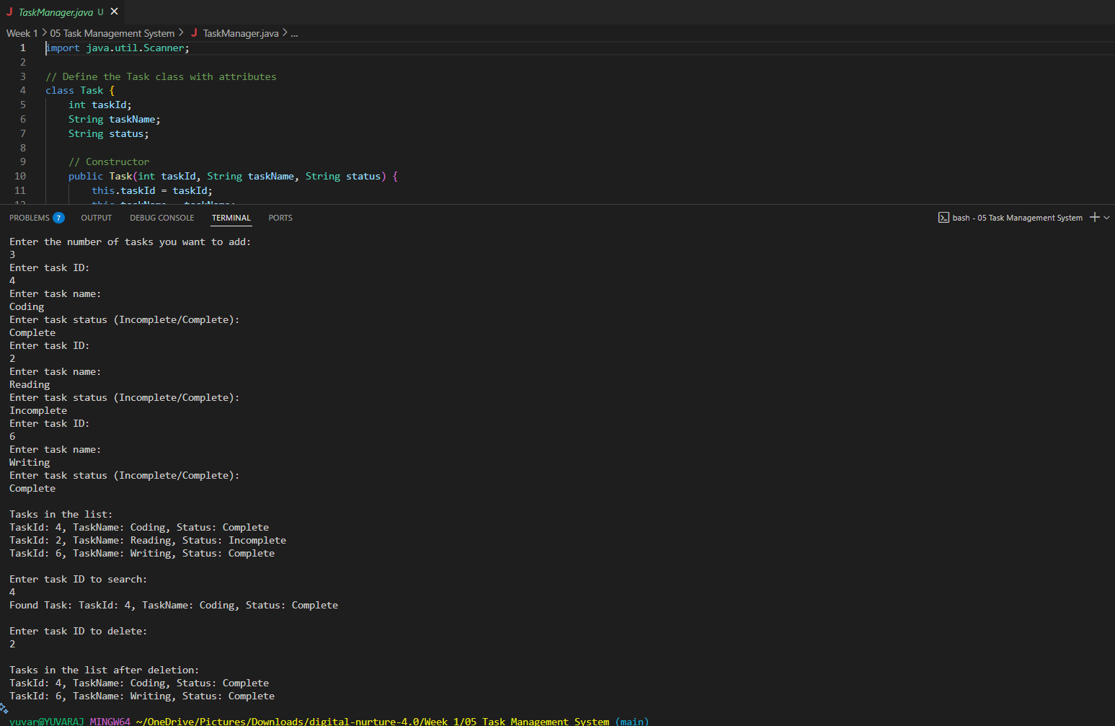OUTPUT: